|  |
| --- |
| Home Page |

Site Map

|  |
| --- |
| Form of opinions |

|  |
| --- |
| Table of celebrities |

|  |
| --- |
| Name |

|  |
| --- |
| Yogurt or ice cream? |

|  |
| --- |
| Height |

|  |
| --- |
| MJ or Lebron |

|  |
| --- |
| Age |

|  |
| --- |
| Pancakes or Waffles? |

Storyboard



|  |
| --- |
| I’m going to have a homepage with my logo and a background image on the first page with a bar at the top which leads you to the other sites |

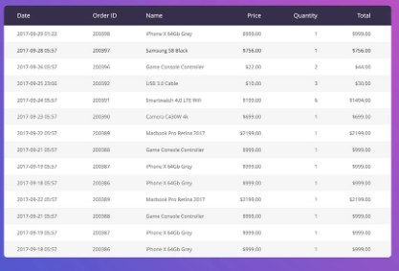

|  |
| --- |
| I am going to have a simple table on the next page that is says what I am going to put in it like celebrity’s height and their name and age |

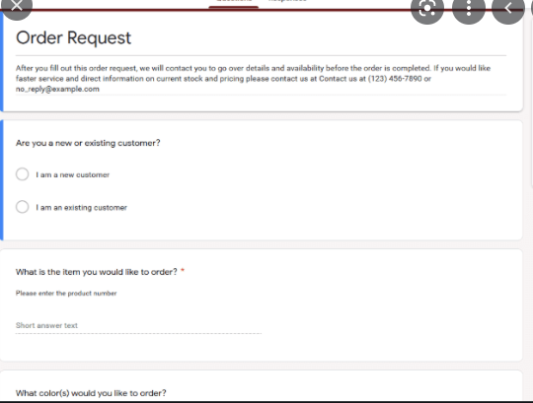

|  |
| --- |
| On the next page after the page of my table ill have my form where it will be asking you food questions/celebrity fit questions |

Form Layout

Waffles or Pancakes?

|  |
| --- |
|  |

Ice cream or Yogurt?

|  |
| --- |
|  |

Michael Jordan Or Lebron James?

|  |
| --- |
|  |

Who is your favorite singer?

|  |
| --- |
|  |

What is favorite food?

|  |
| --- |
|  |

Favorite Tv show?

|  |
| --- |
|  |

Least favorite food?

|  |
| --- |
|  |

Favorite Videogame?

|  |
| --- |
|  |

Favorite car?

|  |
| --- |
|  |

Screenshots

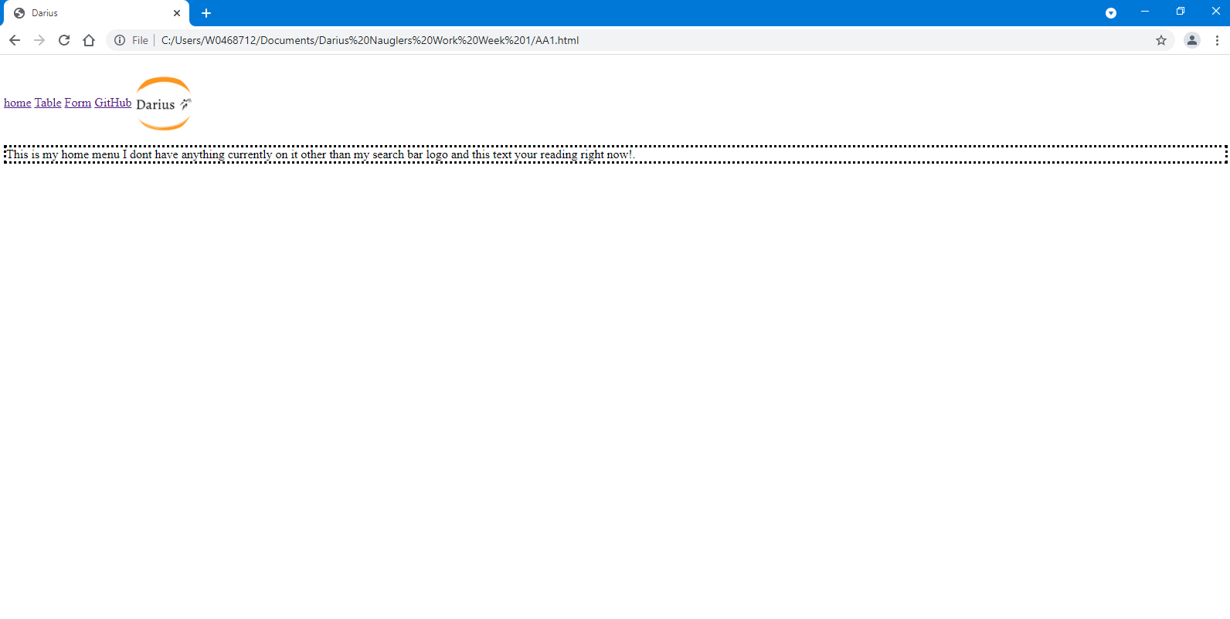

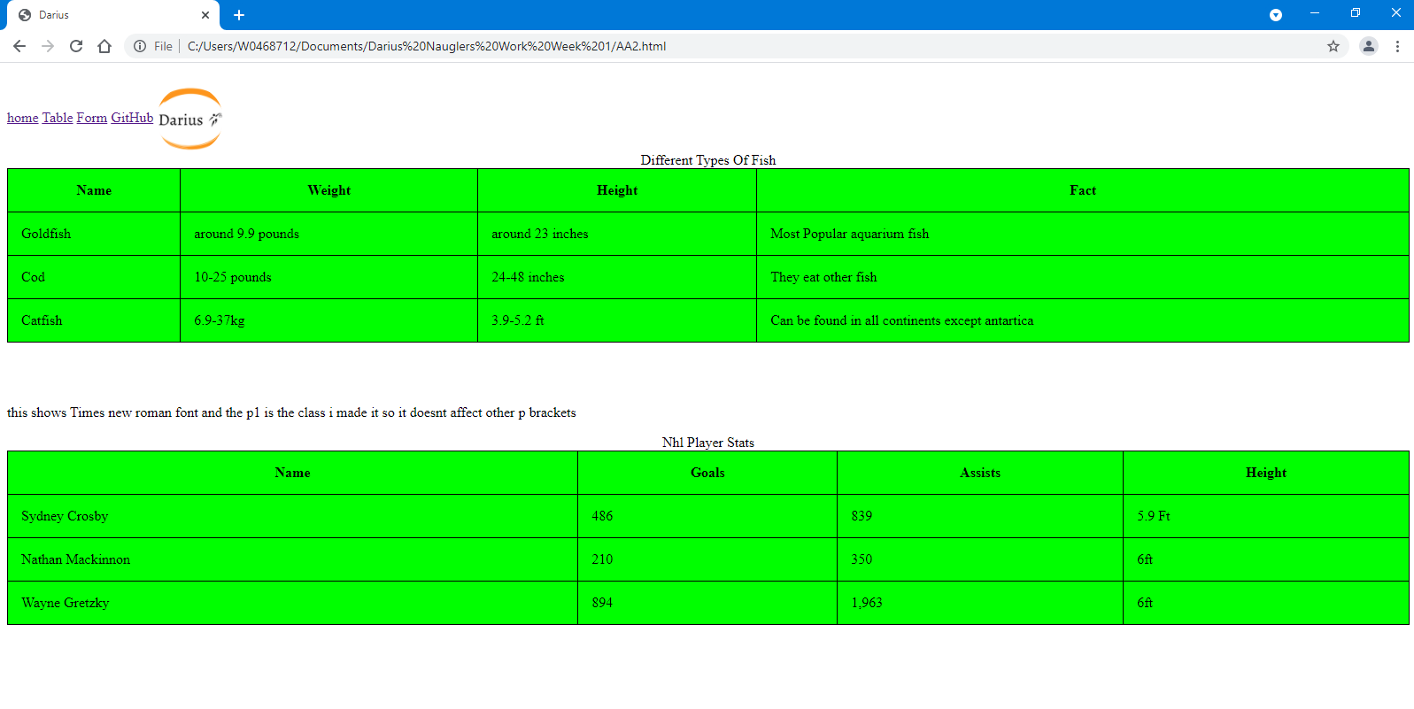

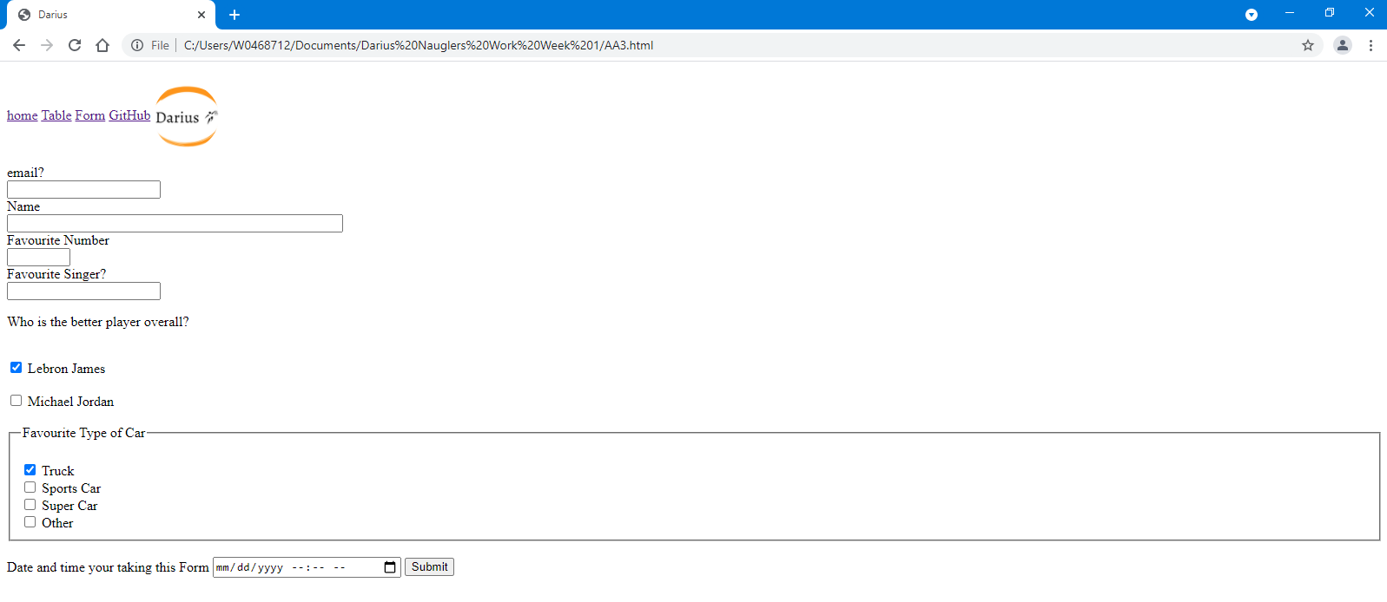

Code 1

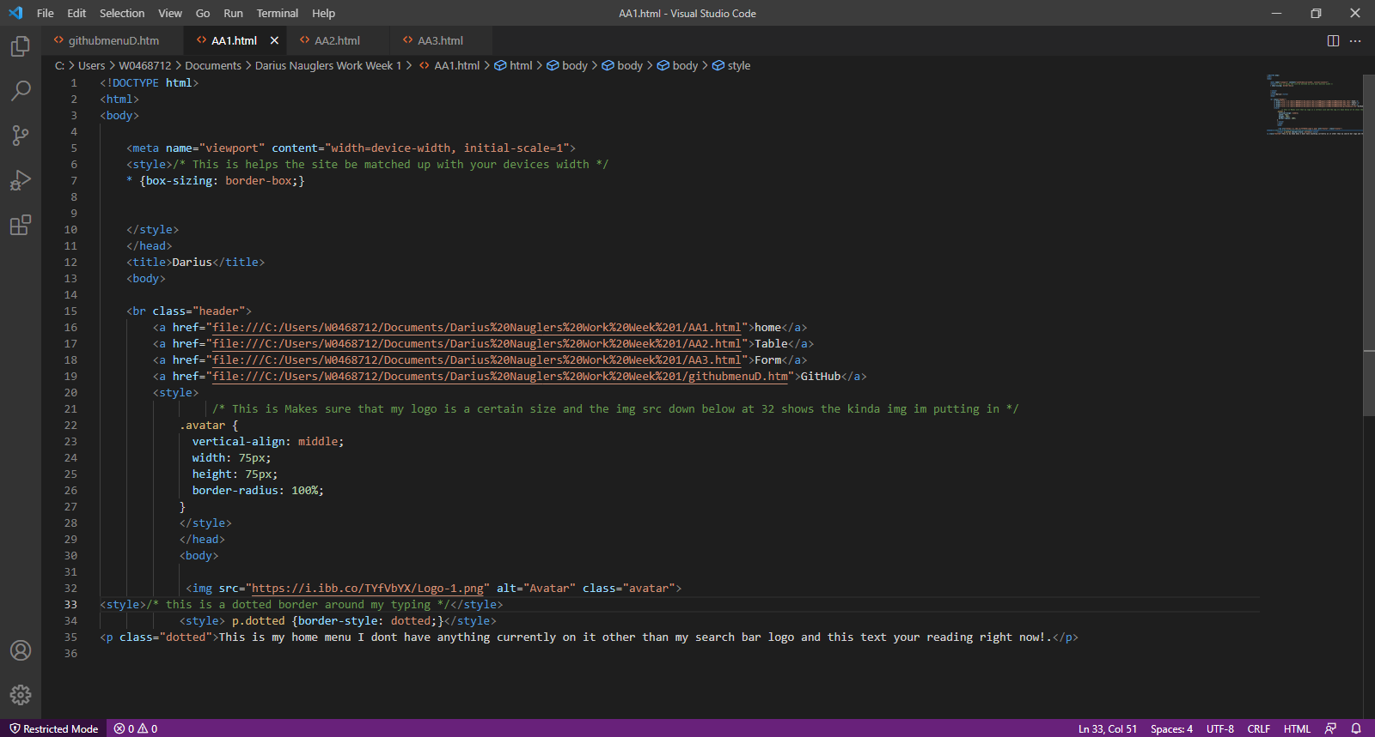

Code 2

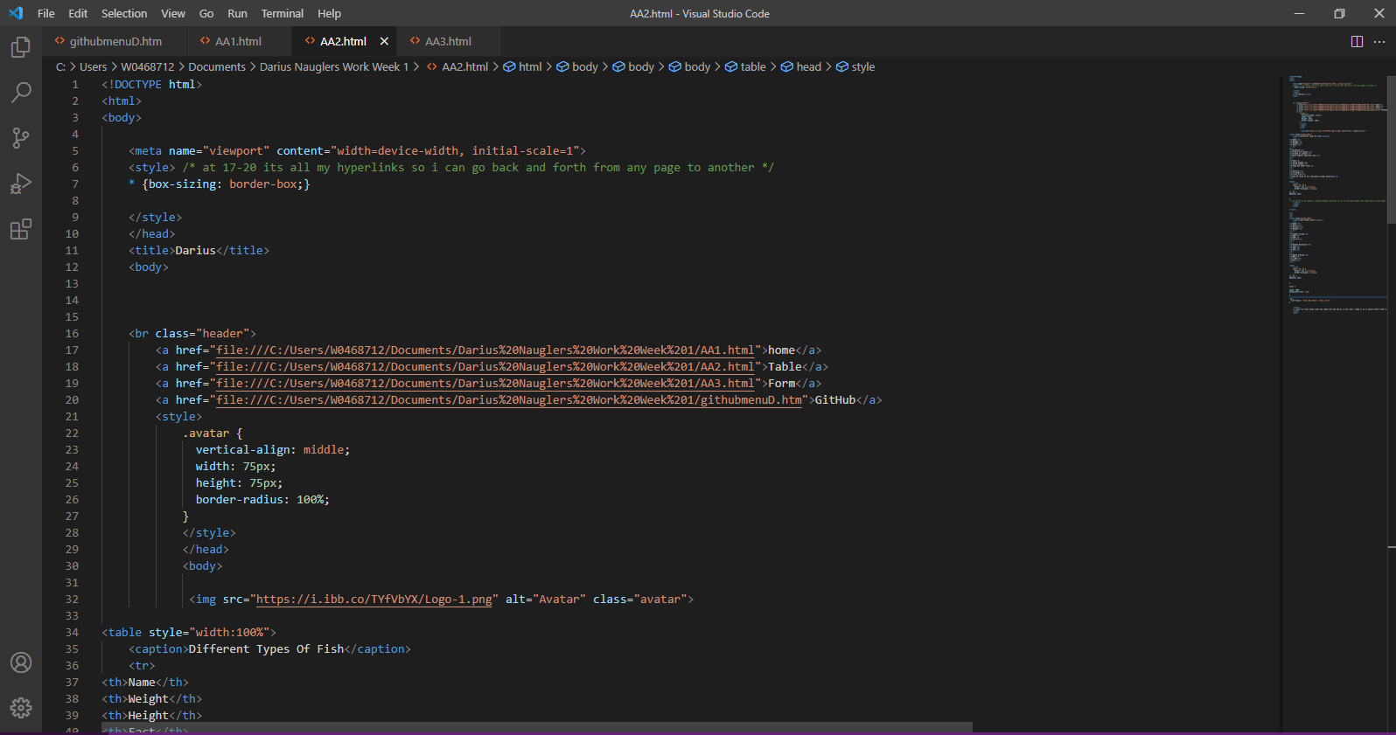

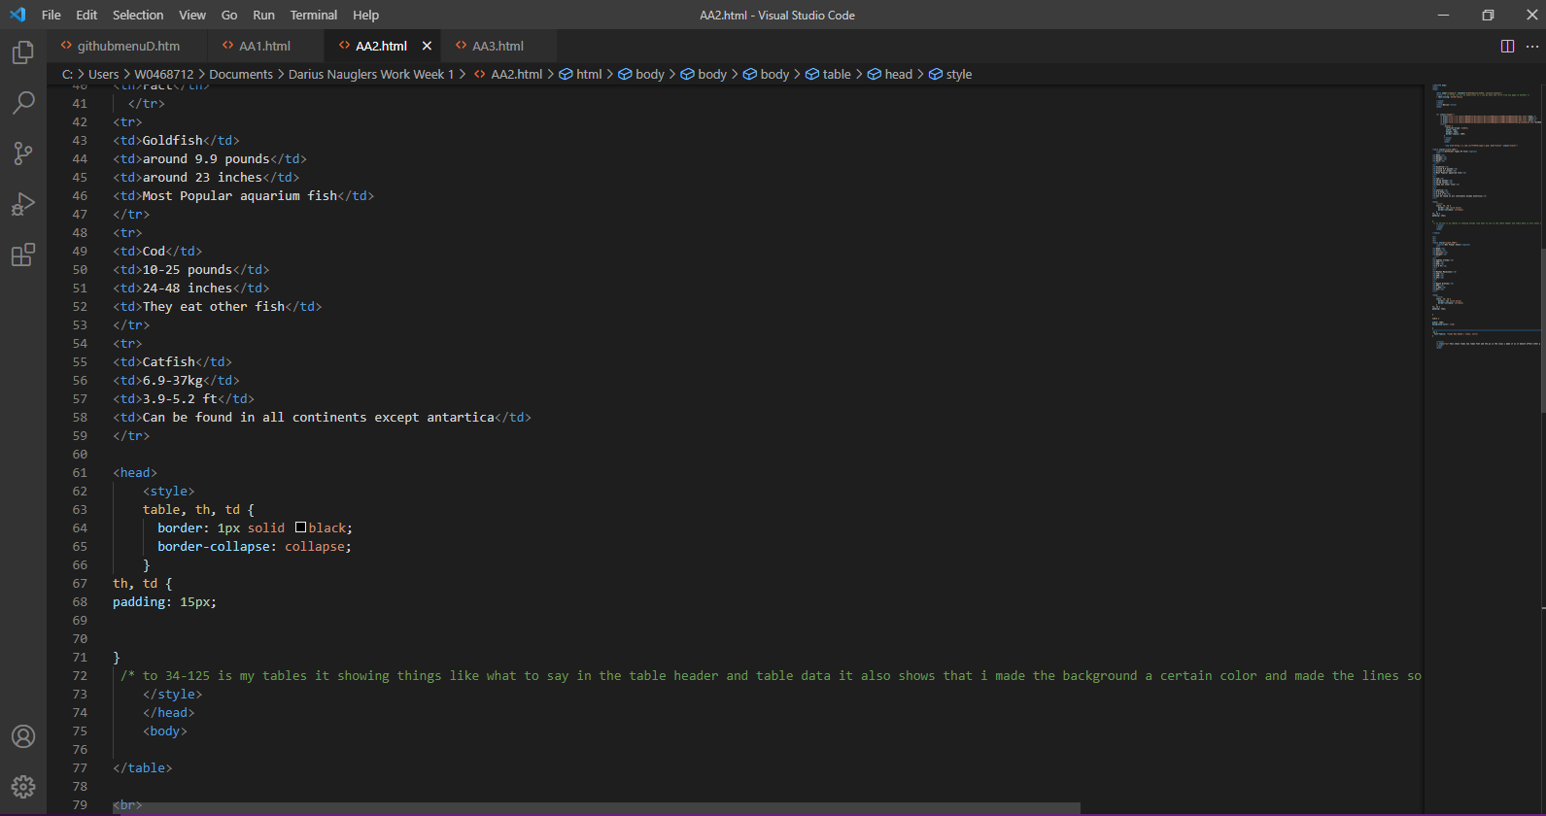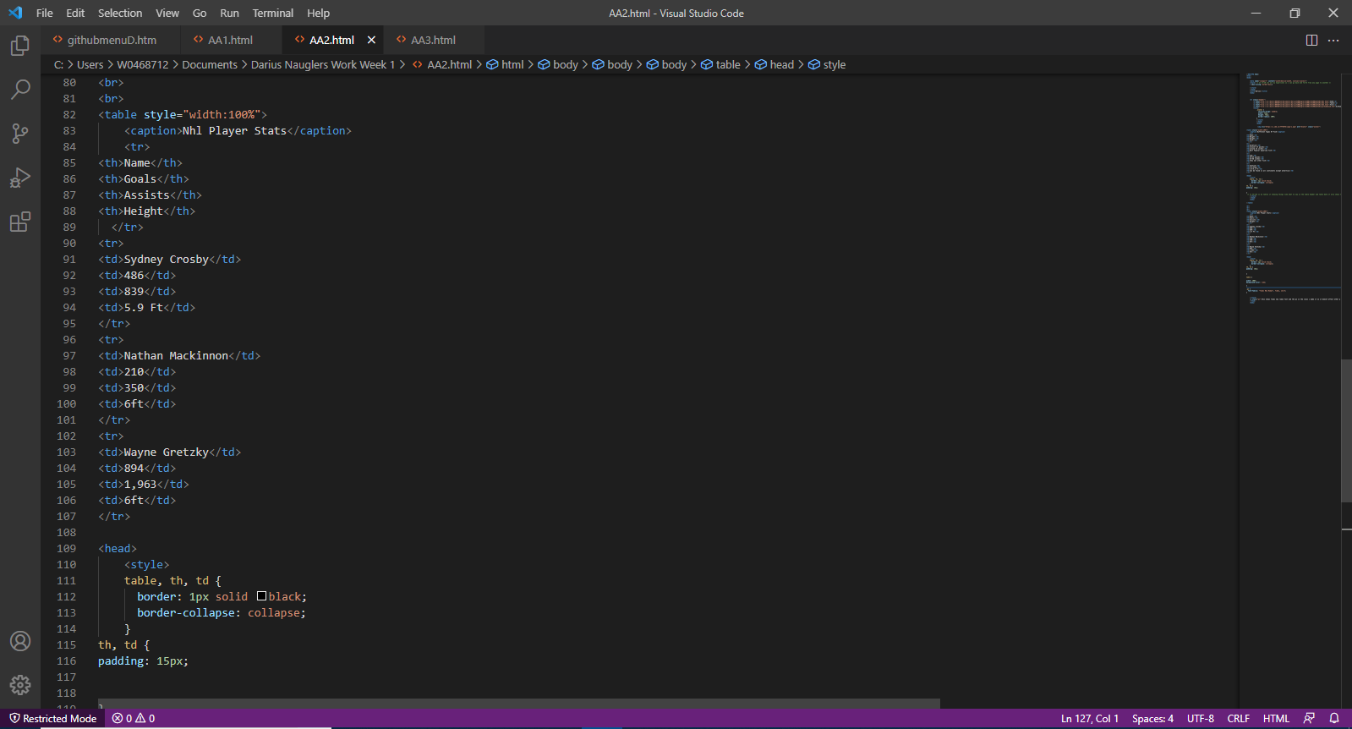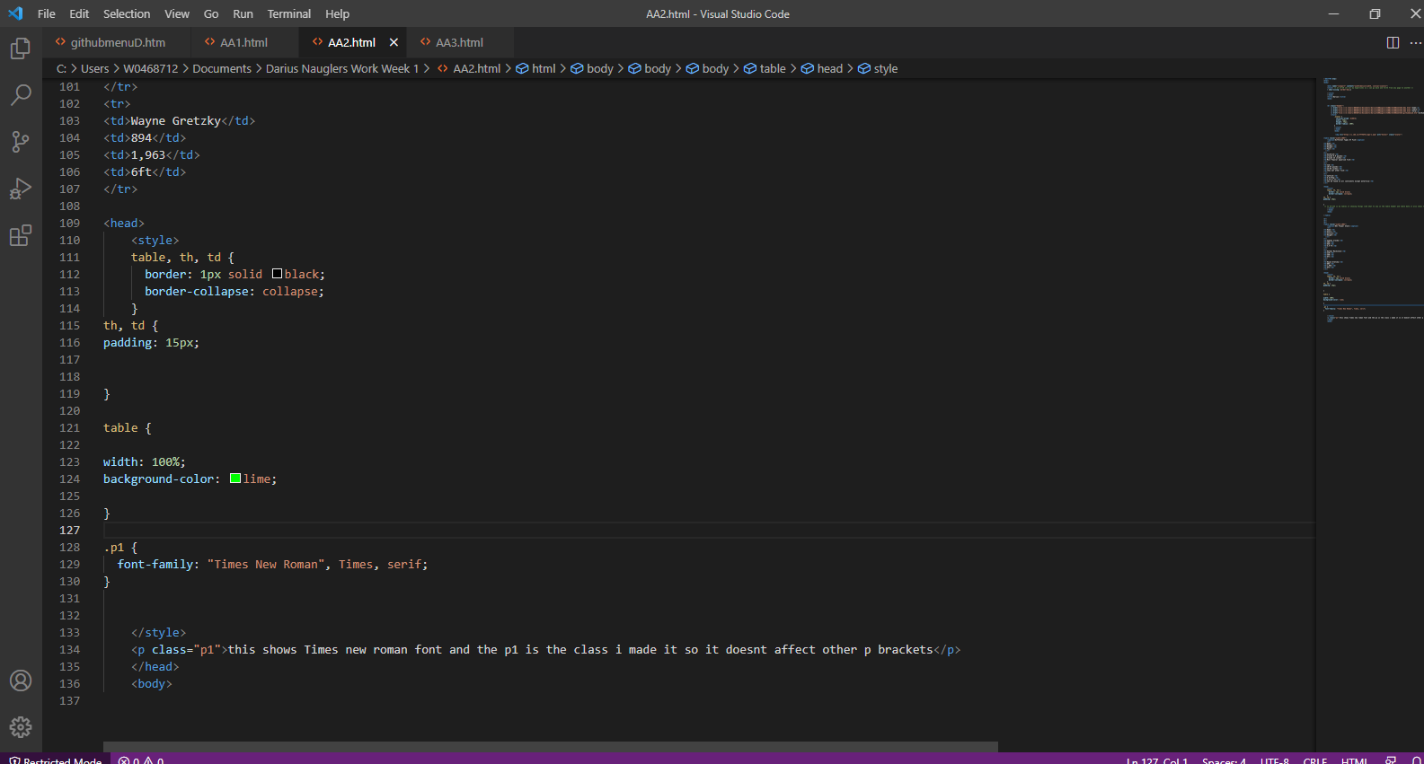

CODE 3

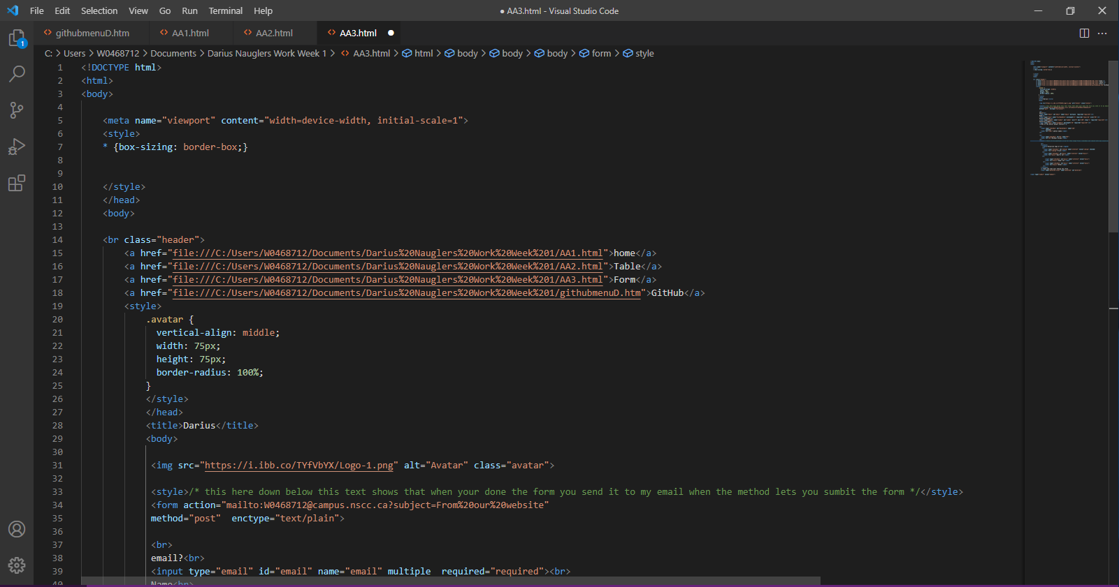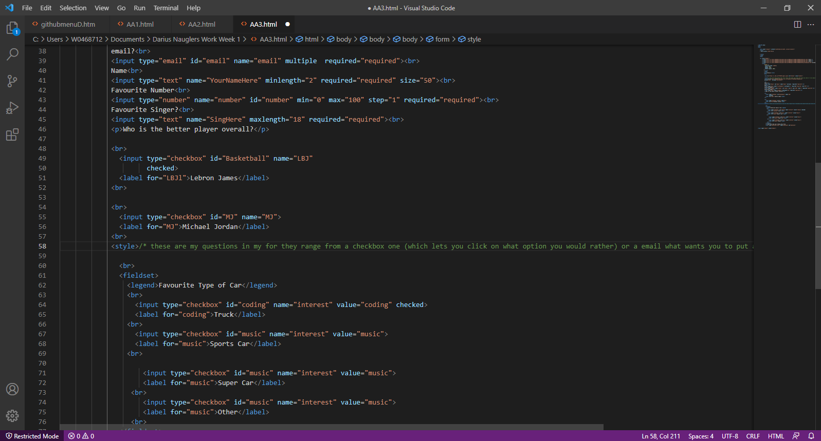

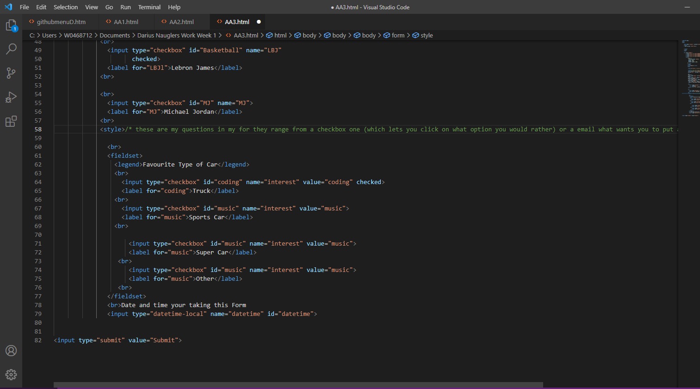

THE END